CS4321: Software Engineering

Group 4: Alfred, Emily, Mat, Merritt

**How to connect to our Database**

Preliminary: You will need JDBC Connector/J in your buildpath in order to perform DB operations with our system.

* <https://dev.mysql.com/downloads/connector/j/>
* Choose Platform independent

1. Go to<https://console.cloud.google.com/sql/instances/cs4321projectdb/overview?project=noted-gift-261118&duration=PT1H>

(You have already been granted administrative access)

2. On the right, click on *Connections*.

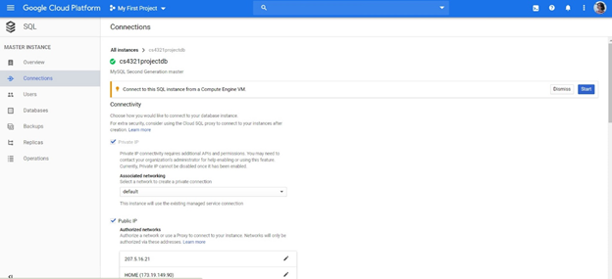

3. Scroll down until you see a list of IP’s. Click *Add network*.

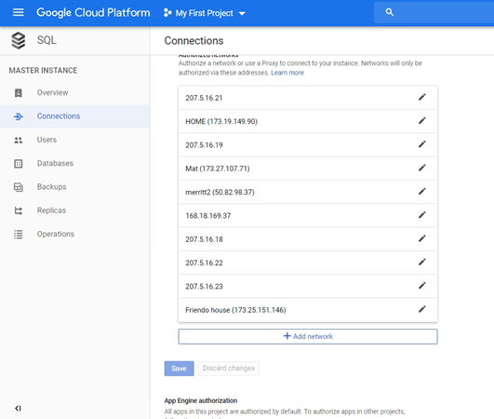

4. Enter your current IP, click *Done*, and then ***Save***.

(I tend to google “What is my ip address”, the db likes that one.)

(Also, the db sometimes takes a few minutes when you save a new IP address. It should indicate when the operation is complete.)

5. To view the contents of the database, we used MySQL Workbench. To connect Workbench to our DB, go back to the Overview page.

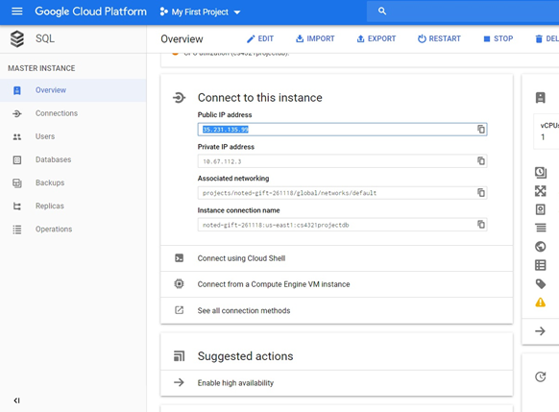

6. Copy the Public IP address, and set that as the hostname for the database in Workbench.

(User: root, password: toor)